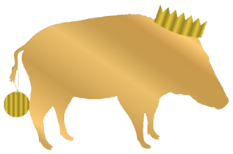
Christmas Fayre Menu
12-9 Monday to Saturday
From Friday 27th November – Saturday 19th December
2 courses £24
3 courses £30

Starters
Winter Vegetable soup, Henllan bread wedge (vg, +*)
Red onion & brie tart, balsamic glaze, watercress salad (vg,gf)
Traditional prawn cocktail, Marie rose sauce, Henllan bread (*)
Bang bang popcorn chicken, yoghurt drizzle, chili & spring onion
Mini Fat Boar sticky pigs in blankets, garlic mayonnaise (*)
Creamed garlic mushrooms, toasted garlic ciabatta (*,vg)

Mains
Garlic & sage roasted turkey, sage & onion stuffing, pig in blanket, buttered Brussel sprout, roast potatoes, rich pan gravy, braised red cabbage, maple glazed root vegetables (*)
Creamy kale, garden pea & spinach risotto, charred tender stem broccoli (+, gf)
Nut roast, cranberry stuffing, Brussel sprouts, chateaux potato, vegan gravy, braised red cabbage, maple
glazed root vegetables (vg)
Seared Seabass, coconut Penang curry, garlic chilli noodles, prawn crackers
Pan fried salmon, buttered new potatoes, hollandaise sauce, minted greens (gf)
Fat boar 8oz festive burger, bacon, brie, sticky pigs, crispy turkey festive fries (*)
12oz sticky glazed bacon chop, poached eggs, hand cut chips, dressed leaves (gf)
8oz Welsh dry aged ribeye steak, roasted tomato & field mushroom, peppercorn sauce, skinny fries (*)
(+£6 supp)

Desserts
Fat boar Christmas pudding, vanilla brandy custard (*)
Double chocolate brownie, vanilla ice cream, chocolate sauce (*+)
Raspberry & white chocolate cheesecake, berry compote, Chantilly cream
Warm Belgium waffle, honeycomb chocolate dust, vanilla ice cream
Citrus tart, crème Chantilly, orange compote

